**(Map and Photos) The project site of Cirebon Coal-fired Power Plant, West Java, Indonesia and the affected community (Photos by FoE Japan / WALHI)**

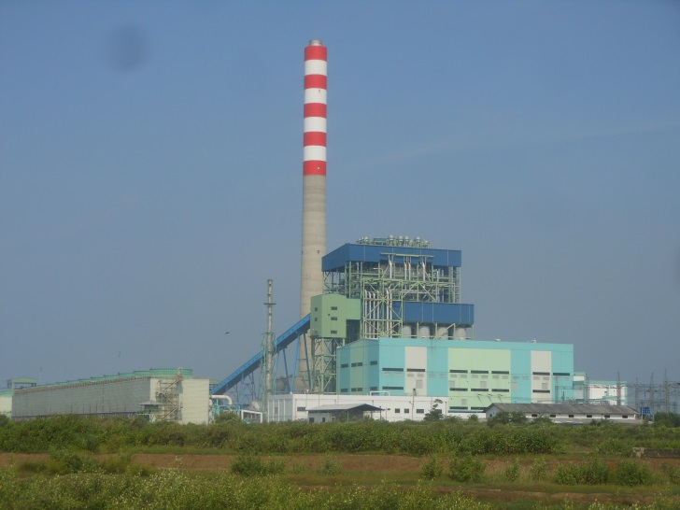

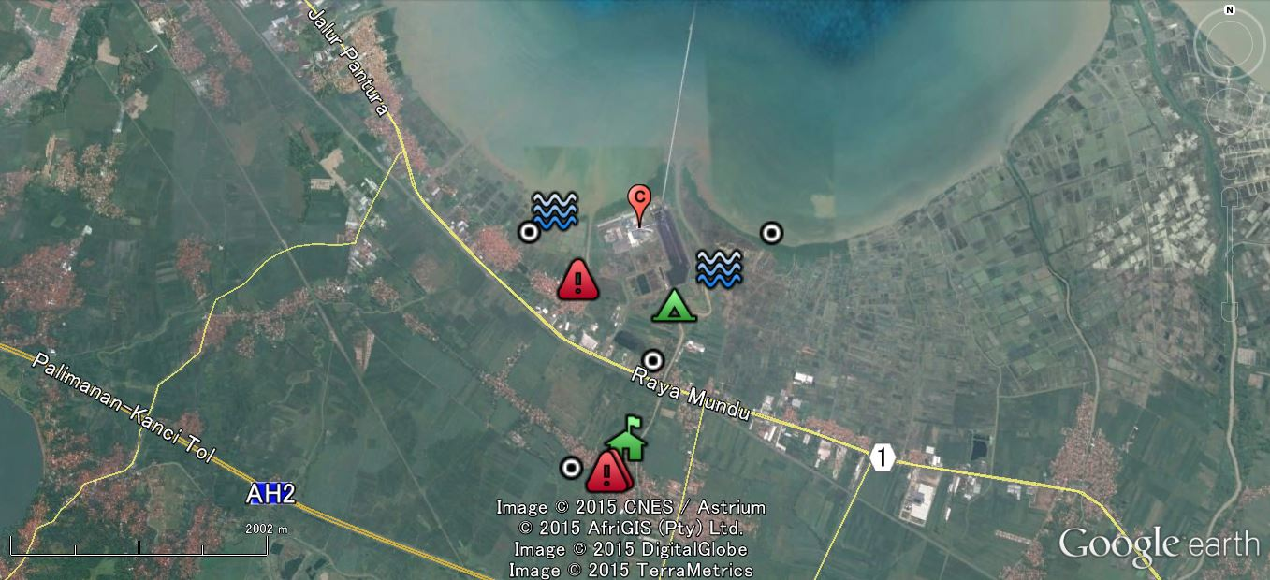

**Salt pans near the power plant. People have been engaging with salt making in dry season, but contamination started to affect there. (August 2015)**

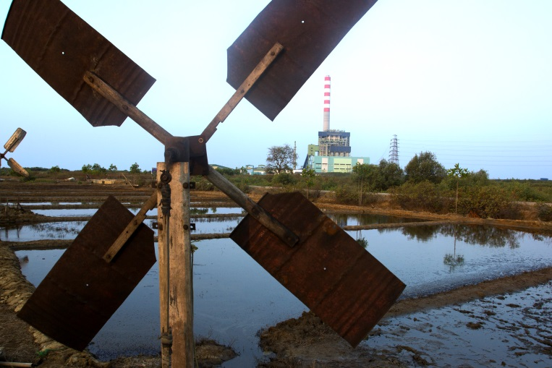

**Within 2 km radius from the stack**

**Within 1 km radius from the stack**

**Cirebon Coal-fired Power Plant**

**Cirebon Coal-fired Power Plant Unit 1:**

Capacity: 660 MW (Super Critical)

　Project Cost: US$ 850 mil

　Proponent: Cirebon Electric Power (CEP)

　　　= Marubeni (32.5%), Korea Midland Power (27.5%),

　　　　Samtan (20％), Indika Energy (20%)

　Finance: JBIC, Korean Ex-im, Private banks

　　　　US$ 595 mil (JBIC = US$ 214 mil)

　Commercial Operation: July 2012

**The fishing area for small-fishermen became smaller due to the construction of the jetty, and fish catches also decreased. (February 2015)**

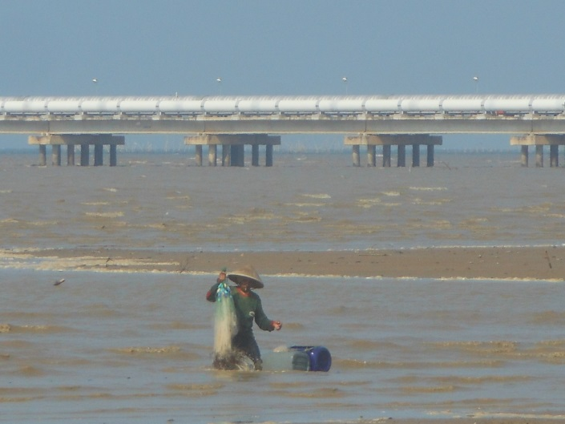

**Farmland adjacent to the coal stockyard, located inside the blue & white screen, in Kanci Kulon. The harvest in rice paddy has decreased sharply. (February 2015)**

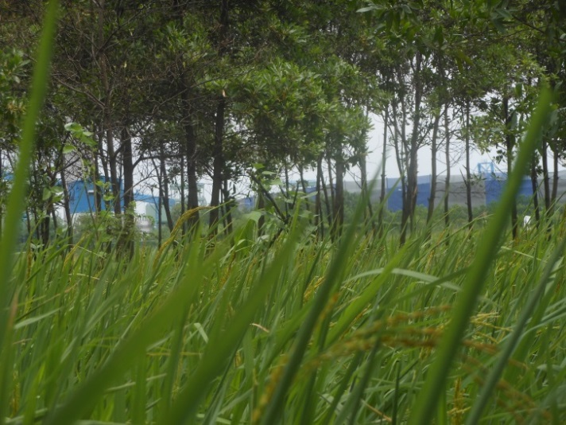

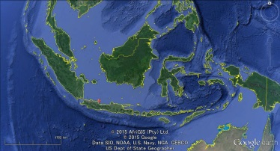**Indonesia**

**コータウン県（次頁参照）**

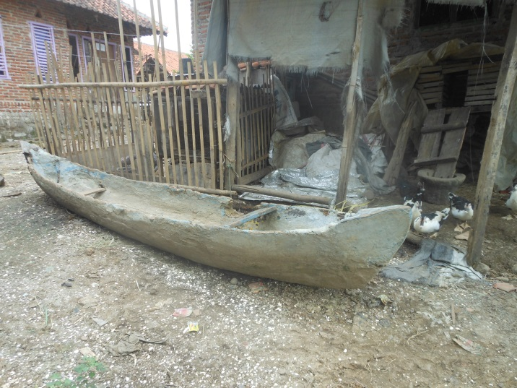

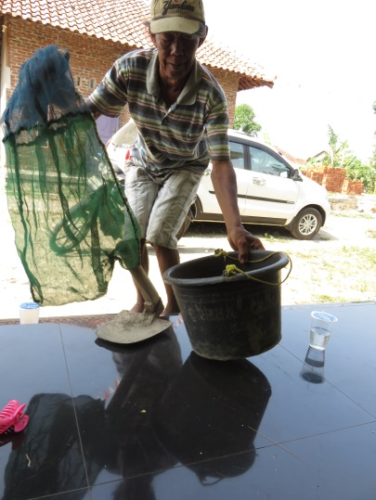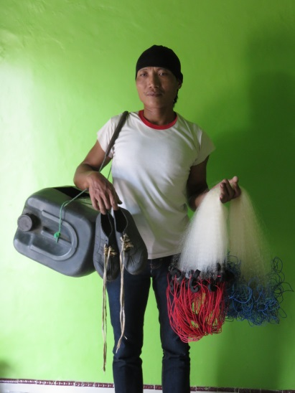

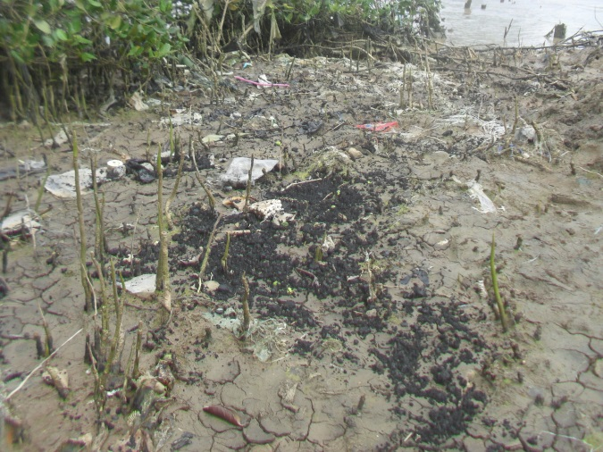

The fishing area for small-fishermen became smaller and fish catches also decreased. In Kanci Kulon, there are small boats which are no more used and left behind. (February 2015)

Before the project, small-scale fishing and shellfish gathering were prosperous along the coast line. The local people in Kanci Kulon showed their tools that they haven’t used anymore. (August 2015)

Coal ash adhered to the shore line of Waruduwur, Mundo. (January 18, 2013, Photo taken by a local fisher man)

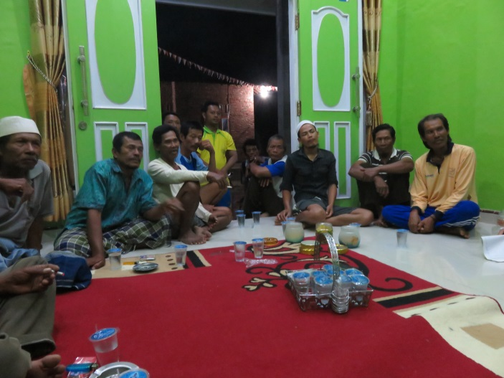

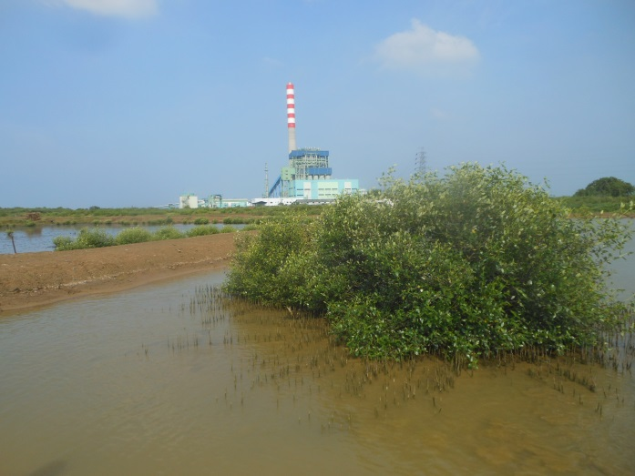

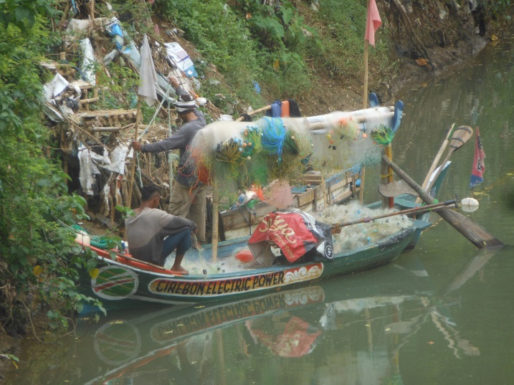

Fish pond in Waruduwur. People are reporting that fish only grows poorer after the project. (February 2015)

CEP provided a few small boats to the small-fishermen in December 2014 as CSR. But the boats were taken back after around 3 months. (February 2015)

Small-fishermen in Kanci Kulon are complaining that fish and prawn catches decreased by less than half, comparing the catches before the project. (August 2015)

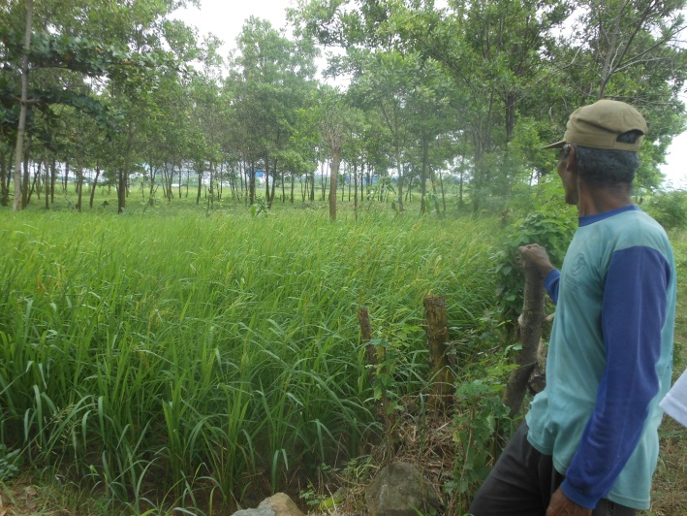

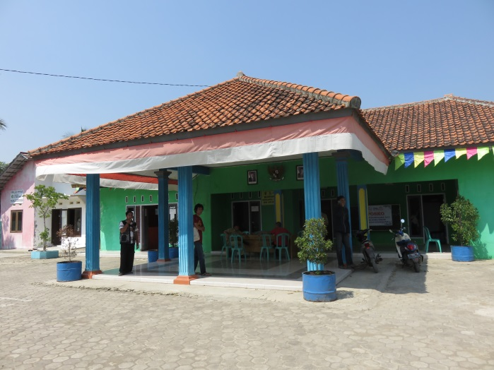

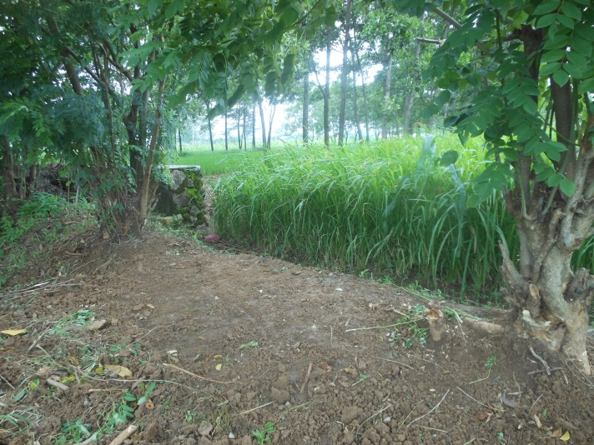

Farmland adjacent to the coal stockyard in Kanch Kulon. Those farmland were supposed to be acquired. But some landowners didn't agree the price of compensation, and the land were not acquired till today. Even though the farmers are continuing their farming, the harvest in rice paddy has decreased sharply. (February 2015)

Farmland adjacent to the coal stockyard, located inside the blue & white screen, in Kanci Kulon. The harvest in rice paddy has decreased sharply. (February 2015)

Kanci Kulon's village building located within 2 km from the stack of power plant. The next building is a elementary school. The villagers has found fly ash after the operation of the power plant. (August 2015)

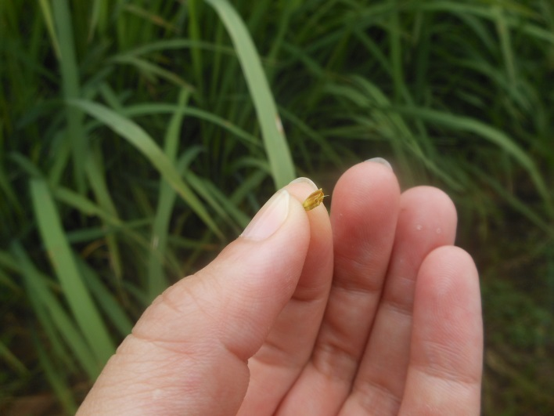

Fly ash which is found in Kanci Kulon's village building. (August 2015)

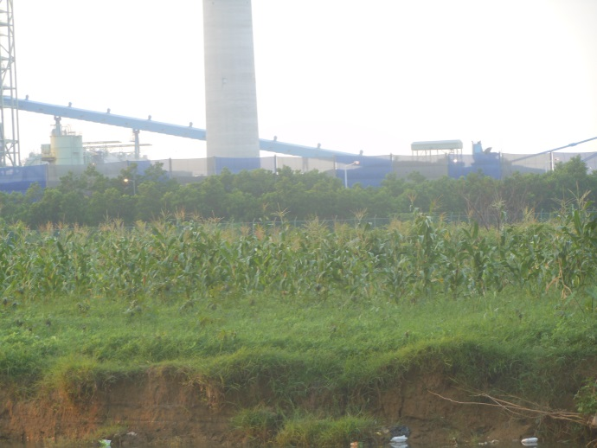

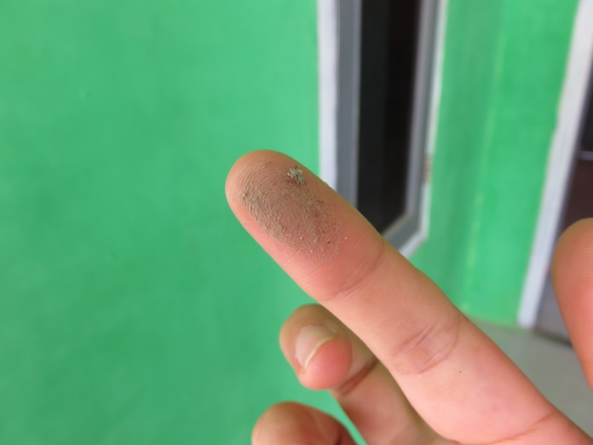

Farmland adjacent to the coal stockyard in Kanci Kulon. Some heads of rice are just empty, and no harvest. (February 2015)

2015年2月）

Farmland adjacent to the coal stockyard in Kanci Kulon. (February 2015)

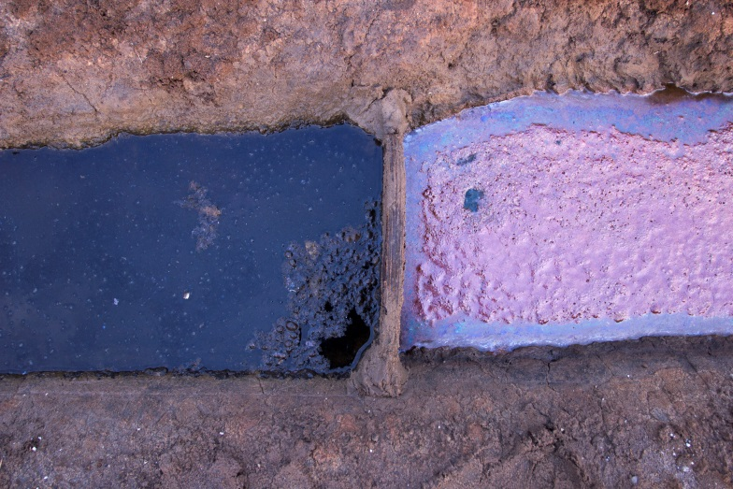

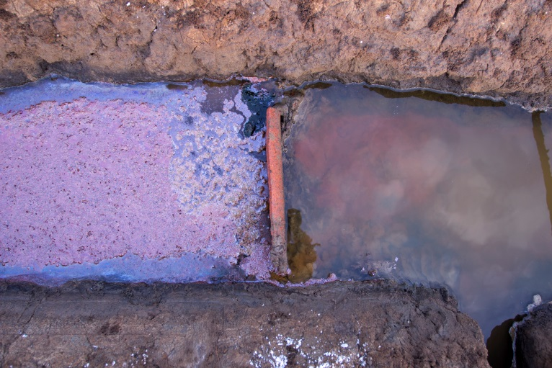

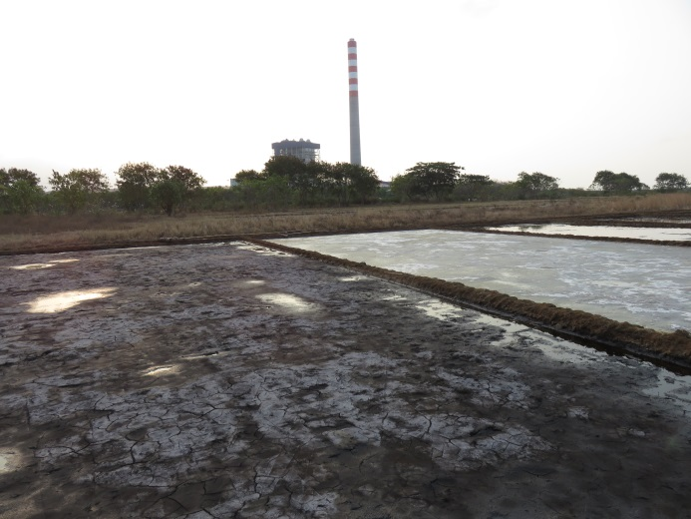

Salt pans near the power plant. People have been engaging with salt making in dry season, but contamination which seems to come through water started to affect there. (August 2015)

As the water for salt pans has been getting darken, the salt makers need to use a few salt pan field to clean (screen) the water, first. Some oil are also found, but the origin is still uncertain. (August 2015)

Salt pans near the power plant in Kanci Kulon. After the project, the amount of product or harvest has been reducing. (February 2015)

As the water for salt pans has been getting darken, the salt makers need to use a few salt pan field to clean (screen) the water, first. (August 2015)

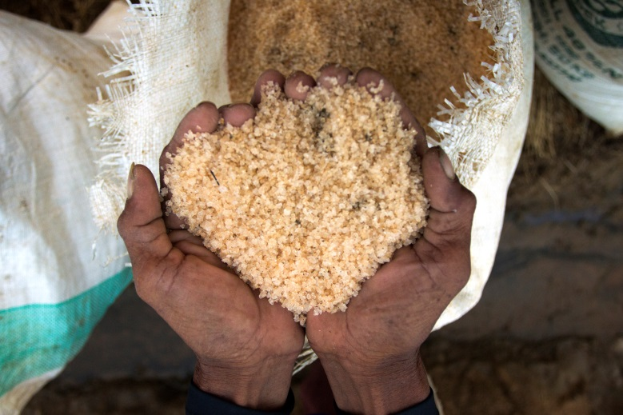

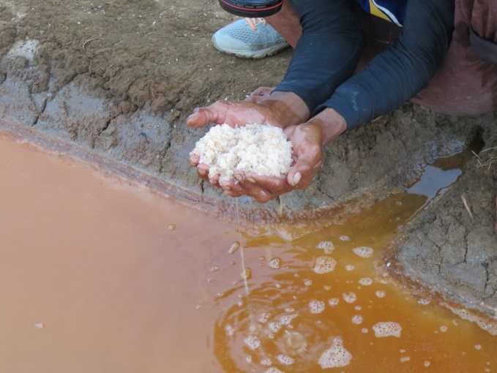

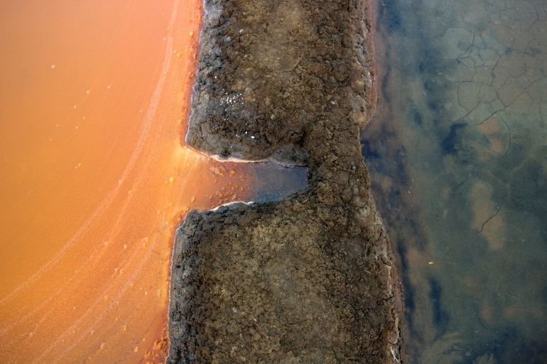

As some dark spots are found in the products from their salt pan, the salt makers need to wash their products, first. It takes longer time than before the power plant project. (August 2015)

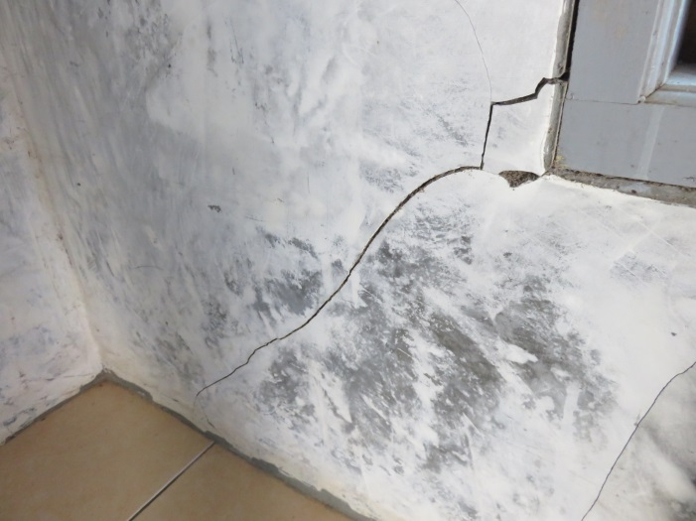

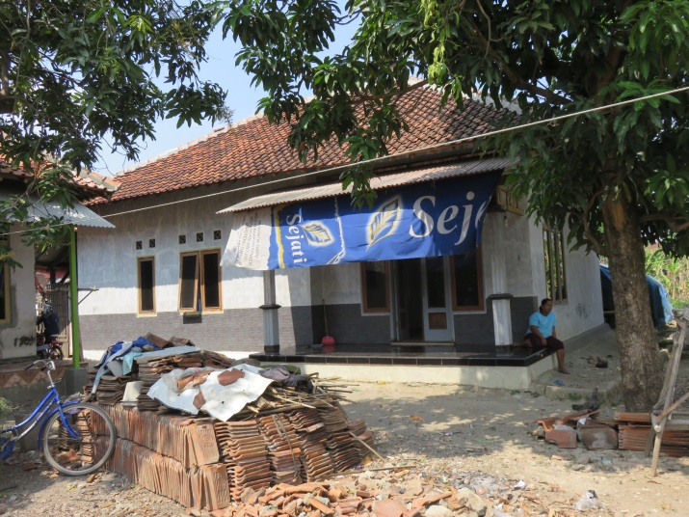

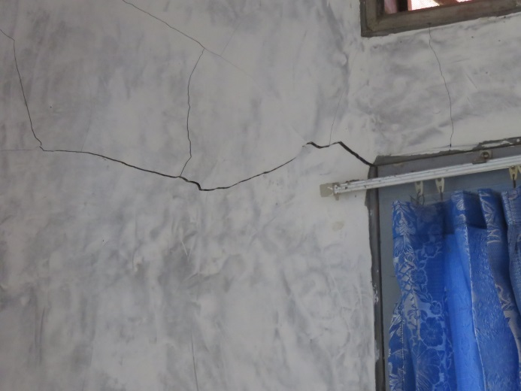

In September 2014, an explosion accident in the plant damaged some houses in Kanci Kulon, Astanajapura, where is located within 2 km from the stack of power plant. This house owner hasn't been provided any compensation by CEP. (August 2015)

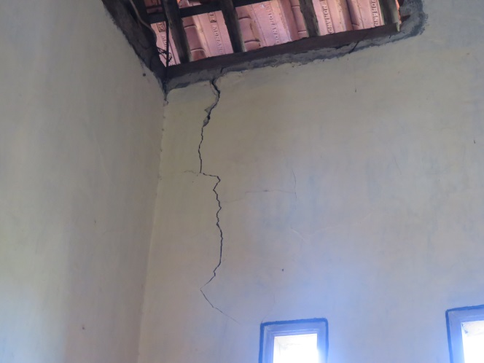

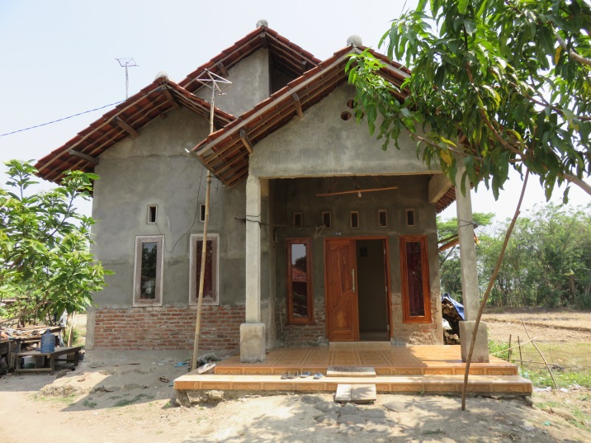

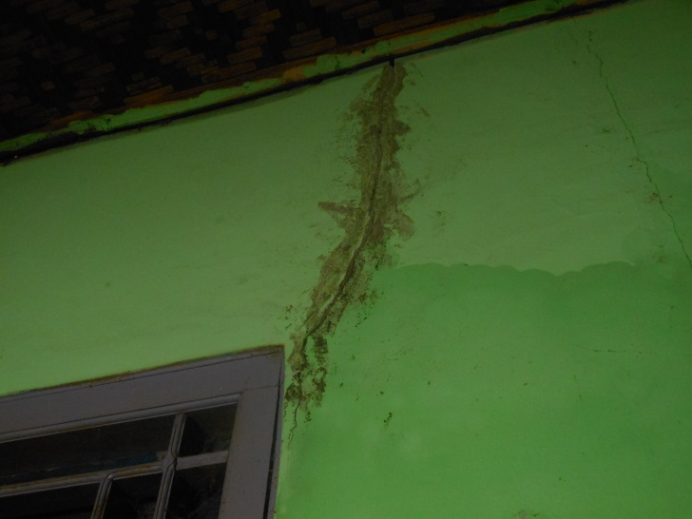

In September 2014, an explosion accident in the plant damaged some houses in Kanci Kulon, Astanajapura, where is located within 1-2 km from the stack of power plant. This house owner hasn't been provided any compensation by CEP. (August 2015)

In September 2014, an explosion accident in the plant damaged some houses in Waruduwur, Mundu, where is located within 1 km from the stack of power plant.. This house owner repaired with his own cost. (February 2015)